Pakistan: 4 killed in attack on Karachi stock exchange

*Security officials kill gunmen who stormed the building in Pakistan's commercial capital.*

by [Asad Hashim](https://www.aljazeera.com/profile/asad-hashim.html)

8 hours ago

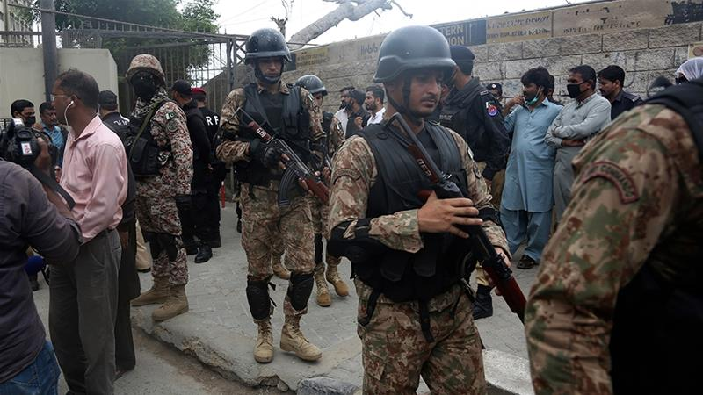

Security personnel surround the Stock Exchange Building in Karachi [Fareed Khan/AP Photo]

MORE ON [PAKISTAN](https://www.aljazeera.com/topics/country/pakistan.html)

* [Pakistan producing own ventilators as COVID-19 cases rise](https://www.aljazeera.com/news/2020/06/pakistan-producing-ventilators-covid-19-cases-rise-200628091242236.html)yesterday
* [Palestinians mourn death of a Bangladeshi war hero](https://www.aljazeera.com/news/2020/06/palestinians-mourn-death-bangladeshi-war-hero-200615111937300.html)2 weeks ago
* [Why a US blogger is at the centre of controversy in Pakistan](https://www.aljazeera.com/news/2020/06/blogger-centre-controversy-pakistan-200613111133977.html)2 weeks ago
* [Pakistan's economy: People-friendly budget as recession looms](https://www.aljazeera.com/news/2020/06/pakistans-economy-people-friendly-budget-recession-looms-200613151657407.html)2 weeks ago

**Islamabad, Pakistan**- Four people were killed after gunmen stormed the Pakistan Stock Exchange (PSX) compound in the southern city of Karachi in an attack claimed by ethnic Baloch separatists that has set off an international row after Pakistan blamed India for supporting the attackers.

Four gunmen attempted to attack the stock exchange building at approximately 10am (05:00 GMT) on Monday morning, firing indiscriminately as they dismounted from their car and charged towards a security barrier at the compound's entrance.

Two attackers were killed at that barrier, security officials said, while the other two were shot dead in an exchange of fire with security officials in the compound's parking lot.

Those killed by the gunmen included three private security guards and a police officer, hospital officials said. At least seven people were wounded in the attack.

"The attackers had hand grenades with them," said Faisal Edhi, head of the Edhi charity and ambulance service, from the scene of the attack shortly after it was ended.

"We were hearing explosions going off."

The PSX building is located in the heart of Karachi's main corporate district, home to the headquarters of several major multinational companies and banks.

Video shot by an office worker in a building opposite the PSX showed the four attackers coming out of a car at the security checkpoint and firing at the security guards.

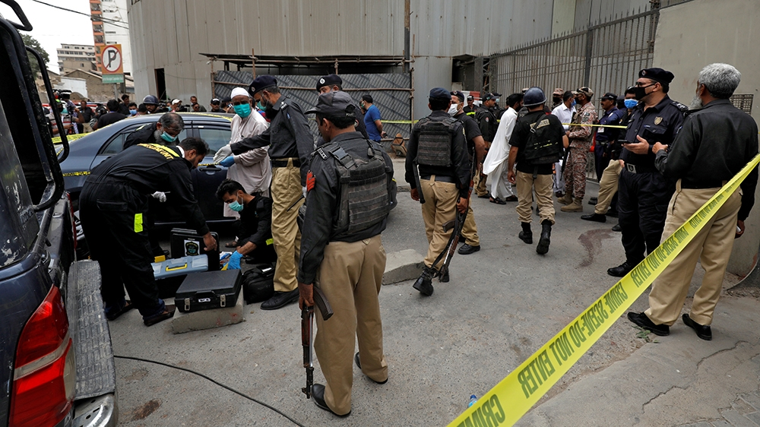

Members of the Crime Scene Unit of Karachi Police prepare to survey the site of the attack at the PSX [Akhtar Soomro/Reuters]

The armed separatist Baloch Liberation Army (BLA) claimed responsibility for the attack in a statement emailed to Al Jazeera, releasing an image of the four attackers.

A senior security official, speaking on condition of anonymity, told Al Jazeera the attack had the hallmarks of previous BLA attacks in the city, notably a November 2018 raid that killed two people when gunmen [attempted to storm](https://www.aljazeera.com/news/2018/11/shots-heard-china-consulate-pakistan-karachi-181123051817209.html) the Chinese consulate in Karachi.

"They came heavily equipped with the purpose, as in those previous attacks, to dig in and set up a siege," the official said. "There were four of them, but luckily they were engaged by the local police deployed there for the security of the stock exchange."

'We are terrified'

Abid Habib, a director at the PSX, told Al Jazeera by telephone that he and 20 other employees took shelter in their offices while security forces swept through the building to locate any additional threats.

"We are all terrified," Habib said. "There was gunfire, and suddenly everyone was rushing to the windows to see what was happening. Because the firing was close by, everyone was very worried, and we closed our outside doors."

The PSX normally houses more than 2,000 employees of both the exchange and associated trading companies, but was operating with reduced staff due to the coronavirus pandemic, PSX official Sulaiman Mehdi told reporters outside the building.

Images from the building showed trails of blood splattered across a staircase and an adjacent corridor inside the building.

Senior police official Sharjeel Kharal told reporters the attackers were killed before entering the building.

"We have cleared the building and handed it over to the local police," he said. "Nothing happened in the main hall."

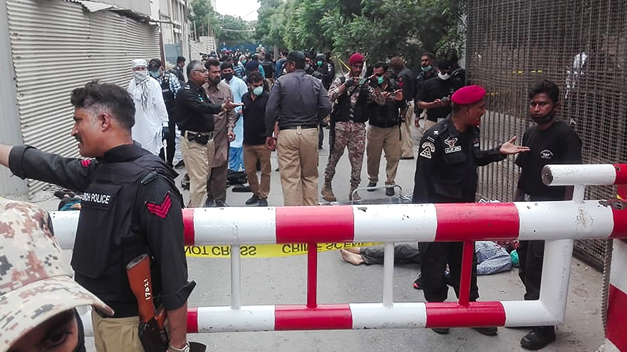

Policemen secure an area around a body outside the Pakistan Stock Exchange building [Asif Hassan/AFP]

Speaking at a press conference following the attack, the chief of the Rangers paramilitary force - which led the security response - said the attackers were killed within eight minutes of attempting to storm the exchange.

"They wanted to attack such a prominent target ... to show that Pakistan is an unsafe country and to shatter the confidence of investors," said Major-General Omer Ahmed Bukhari.

Trading continued unabated at the PSX through the course of the attack, the market's electronic systems continuing to function online. The market closed 0.71 percent up at 34,181.80 points.

Later on Monday, Pakistani Foreign Minister Qureshi was quoted by local media as having accused India of operating "sleeper cells" to conduct attacks on Pakistani soil. Moeed Yusuf, the prime minister's special assistant on national security, also pointed the finger of blame at Pakistan's eastern neigbhour, saying there was "an established link" between the BLA and India.

India swifty rejected the comments as "absurd", saying "Pakistan cannot shift the blame on India for its domestic problems".

Baloch separatism

Ethnic Baloch separatists have been fighting the Pakistani state for more than a decade, demanding independence for ethnically Baloch areas of Balochistan, Pakistan's largest and least-populated province, which is rich in mineral deposits.

The BLA, one of the larger armed groups in the rebellion, has previously claimed responsibility for several major attacks targeting Pakistani civilians and security forces.

In May 2019, BLA gunmen [stormed a luxury hotel](https://www.aljazeera.com/news/2019/05/gunmen-attack-hotel-pakistan-port-city-gwadar-190511134034253.html) in the Pakistani port town of Gwadar, killing at least five people.

Violence in Pakistan has been reduced sharply in the last three years, as the country's security forces launched wide-ranging security operations against armed groups across the country, mainly targeting the Tehreek-e-Taliban Pakistan (TTP) and its allies, but also including other groups such as the BLA.

In its statement after Monday's attack, the BLA said the objective "was to target the Pakistani economy".

"Pakistan's economy is based on the exploitation and genocide of the Baloch nation and the Karachi Stock Exchange is a foundation and symbol of this exploitative economy," it said.

"This attack is not only an attack on Pakistan's economic interests but also an attack on Chinese economic interests, in response to China's exploitative plans in Balochistan. It serves as a warning that if China continues to be involved in Baloch exploitation, and continues to support Pakistan's genocide of the Baloch, then the attacks of Baloch [fighters] on Chinese interests will intensify."