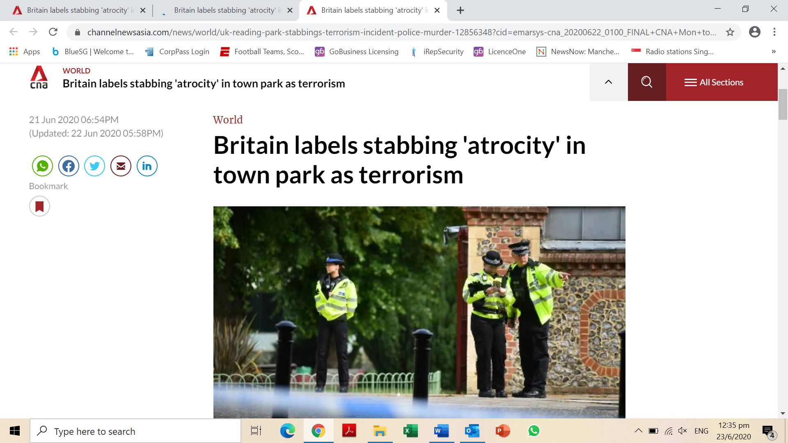

LONDON: A stabbing rampage in the southern English town of Reading in which three people were killed and three taken to hospital was an act of terrorism, police said on Sunday (Jun 21), calling [the attack in a sunny park](https://www.channelnewsasia.com/news/world/uk-police-report-injuries-stabbing-incident-reading-12855634) an atrocity.

"Counter Terrorism Policing can now confirm that the stabbing incident that happened in Reading last night, has now been declared a terrorist incident," Thames Valley Police said in a statement.

Detectives said a man had run into a park in Reading, about 40 miles (65km) west of London where locals had been enjoying the evening sun on Saturday, and attacked people with a knife before being tackled by unarmed officers five minutes after they were alerted.

Police said an unnamed 25-year-old man who had initially been detained on suspicion of murder had since been re-arrested under the Terrorism Act. He remains in police custody.

"The investigation continues to move at a fast pace," said Detective Chief Superintendent Kath Barnes, head of the regional counter-terrorism unit.

A Western security source, speaking on condition of anonymity, told Reuters that the arrested man was a Libyan called Khairi Saadallah.

Advertisement

The security source said Saadallah had [come across the radar of Britain's domestic security agency](https://www.channelnewsasia.com/news/world/security-questions-after-three-die-in-uk-knife-attack-including-12858846) MI5 last year over intelligence he had aspirations to travel for extremist purposes, although his plans came to nothing.

He never met the criteria for a full investigation, the source said.

Initially police and the government had said the attack did not appear to be terrorism. But Britain's most senior counter-terrorism police officer, Neil Basu, said officers had worked through the night and had now declared it to be a terrorist incident.

"This was an atrocity," Basu said. "From our enquiries undertaken so far, officers have found nothing to suggest that there were any other people involved in the attack, and presently, we are not looking for anyone else in relation to this incident."

**"APPALLED AND SICKENED"**

While the motivation for the attack was unclear, he said there was no intelligence other crowded places were at risk.

One of the victims of a stabbing attack in the English town of Reading on Saturday was a US citizen, the Philadelphia Inquirer reported on Monday.

The Philadelphia Inquirer named the victim as Joe Ritchie-Bennett, 39, who had lived in Britain for 15 years.

British teacher James Furlong, 36, has also been named as one of the victims.

Prime Minister Boris Johnson said he was "appalled and sickened" by the attack and said Britain would change the law if needed to prevent any future incidents.

"If there are lessons we need to learn ... we will learn those lessons and we will not hesitate to take action if necessary," he said.

“Incidents of this nature are very rare, though I know that will be of little comfort to those involved and understand the concern that this incident will have caused among our local community," said chief constable John Campbell.

Campbell urged members of the public to refrain from speculation and said the authorities would like to hear from anyone who has video footage of the incident.

"Out of respect for those deceased and injured, along with their loved ones, please do not circulate this footage on social media – this will be incredibly distressing," he added.

The attack took place after a Black Lives Matter rally by anti-racism protesters in the park which concluded three hours earlier but Basu said the two incidents were not related.

"In terms of the protest and the people who attended from Black Lives Matter, we're all safe," the Reading BLM event organiser Nieema Hassan said on Facebook.

"None of us are affected. We had all left by the time this happened."

**PEOPLE WERE STABBED "AT RANDOM"**

Witnesses previously reported seeing two air ambulances and several police cars rush to the park on Saturday evening.

One witness described a lone assailant walking through a park filled with people relaxing on the grass and stabbing them at random.

"The park was pretty full. A lot of people sat around drinking with friends," Lawrence Wort told the Press Association.

"One lone person walked though, suddenly shouted some unintelligible words and went around a large group of around 10, trying to stab them."

Wort said he saw three people being stabbed "in the neck and under the arms".

The assailant then lunged at another group and "got one person in the back of the neck", Wort said.

Another witness told The Sunday Mirror that one group of people who were attacked were "just in a circle chatting".

The assailant "was tapping them on the head. Then I thought someone had been sick. But it was blood spraying out,' said the witness.

Paramedic teams were seen trying to resuscitate the injured as they lay unresponsive on the ground.

Home Secretary Priti Patel called it "a senseless attack on people enjoying a Saturday evening with friends".

Britain has witnessed two terror-related attacks in the past year.

A [convicted extremist](https://www.channelnewsasia.com/news/world/uk-end-early-release-convicted-terrorists-london-bridge-attack-12294168) who was out on parole after serving a sentence for terror offences was shot dead by police after stabbing five people - two fatally - by [London Bridge](https://www.channelnewsasia.com/news/world/london-bridge-stabbing-usman-khan-victim-uk-12142534) in the heart of the British capital in November.

Police killed another assailant who injured three people in a [London stabbing attack](https://www.channelnewsasia.com/news/world/man-shot-by-police-terrorist-related-london-stabbing-12383688) in February.

An overwhelming majority of Britain's serious crimes are committed with knives and other stabbing weapons because of very strict gun ownership laws.

Johnson's Conservative government promised to toughen up penalties for terror-related crimes after winning a sweeping mandate in a December general election.

*Source: Agencies/CNA/zl*