### Letter of the day

# Challenges with Progressive Wage Model in the security sector

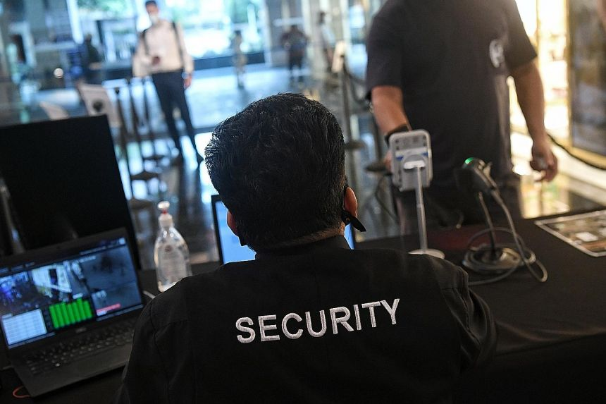The writer says that although a security officer can attend courses and upgrade himself to earn a higher basic wage as a senior security officer, security supervisor or senior security supervisor, in reality, there is very little demand for these roles because many clients want only the cheapest option - a security officer.ST PHOTO: KUA CHEE SIONG

* PUBLISHED

JUN 15, 2021, 5:00 AM SGT

I agree that the Progressive Wage Model (PWM) for low-income workers is a good initiative (Helping low-wage workers climb wage ladder, June 12).

However, at the same time, I feel sad to say that the good intentions behind the initiative do not resonate with my experiences on the ground.

Let me use the security sector as an example.

The minimum basic wage recommended in the PWM for a security officer (the lowest job grade) is $1,400, and the Police Licensing and Regulatory Department has made it mandatory for all security agencies to comply with the PWM.

As of Sept 1, 2016, security agencies must meet the PWM requirements to obtain or renew their licences.

Employers in the security industry generally follow this rule strictly and set the basic wage for all security officers at $1,400.

Therefore, a security officer will draw a monthly salary of about $1,120 (after Central Provident Fund deduction) without overtime work. How can a Singaporean have a decent standard of living with just $1,120, considering the high cost of living here?

Let's look at the progressive part of the PWM.

When a security officer attends courses and upgrades himself, his minimum basic wage will increase progressively - senior security officers get $1,585, security supervisors get $1,785, and senior security supervisors get $1,985.

However, in reality, there is very little demand for senior security officers, security supervisors or senior security supervisors because many clients want only the cheapest option - a security officer.

Hence, many, even after upgrading themselves, can continue to work only as a security officer, with no change to their basic wage of around $1,400.

The situation is further aggravated if work permit holders who have upgraded themselves are given priority in these positions.

This can happen as the PWM wage guidelines are not mandatory for foreigners, and employers can choose to pay them a lower wage.

Many Singaporeans who had lost their jobs owing to the Covid-19 pandemic and entered the security sector are now in this predicament.

I am inclined to believe that the PWM is sustainable only if the wage recommendations are lowered to make them more sustainable.

It is the responsibility of the Government to ensure that Singaporeans, no matter what social stratum they are in, are paid fairly. This is what the PWM was formulated for.

**Vijayakumar Kassi**